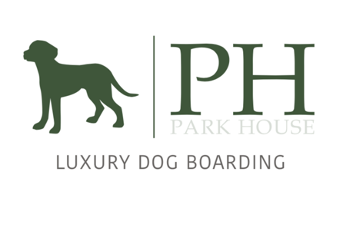
Medication Consent form

Before your dog comes to stay at Park House please can you print and fill this form out if your dog is on any medication. Can you please bring the medication in its original packaging so Kate and the other staff can see what the vet's dosage is on the medication.

One form per medication please.
(if your dog is on multiple meds, please print multiple forms)

Name of medication:

Dosage of the Medication

Tick for how often your dog needs to receive their medication

- Am
- Lunch
- Pm
- Specific times (tell us underneath the times you would like your dog to receive their medication)

Please give us a small description of how you get your dog to take the meds:

Is the medication for the full duration of your dog’s stay:
- YES – I have supplied plenty to last the duration.
- NO – It will run out during the stay.
- YES – I need Park House to collect more from my Vet

Sign and print for that you give us permission for us to administer medication.

Date:

Print:

Sign:

